A Spring Visit to Bear Spring Camps: Belgrade, Maine

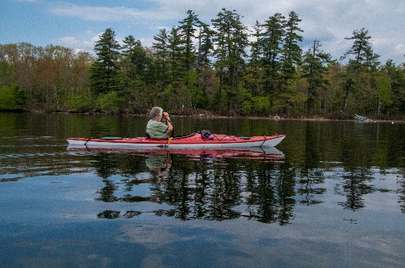

Spring brings many changes, but one thing has been constant this year: clouds, rain, and high winds. This Spring weeklong trip north to begin a season of kayaking and outdoors activities provided us with all three treats! Even so, we enjoyed kayaking every day, catching several real nice bass, meeting old friends and acquaintances, and several rather exciting kayak runs in high winds and 51 degree lake water. The week at the Bear Spring Camps brought wonderful tranquility, excellent daily dining menus, and smooth fireplace burns with enjoyable reading.

And for the photos, click on the [Bear Springs - May, 2019](https://photos.app.goo.gl/a23caxmHbATZU12b8) and feel free to enlarge.